Q1.
Answer is C.

A: Syntax error: WHERE cannot be used after GROUP BY.
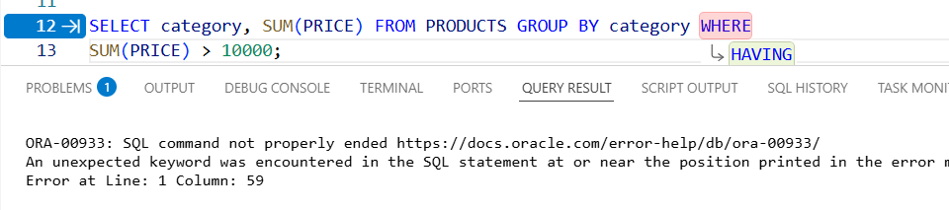

B: Syntax error: WHERE cannot contain aggregate functions; also GROUP BY must come before HAVING.
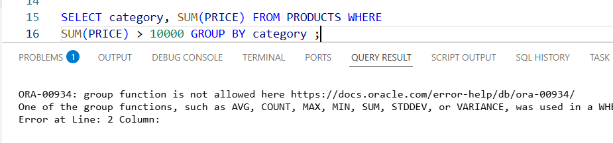

C: Correct.
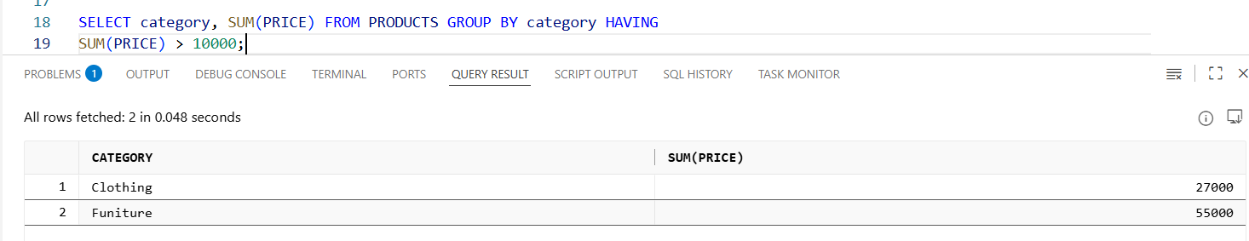

D: Also Correct. Work in Latest Oracle version.
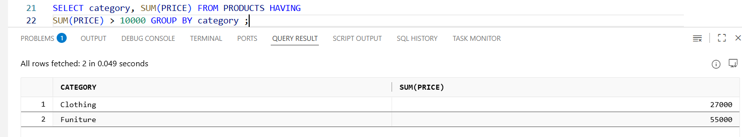

Q2.
Answer is C.

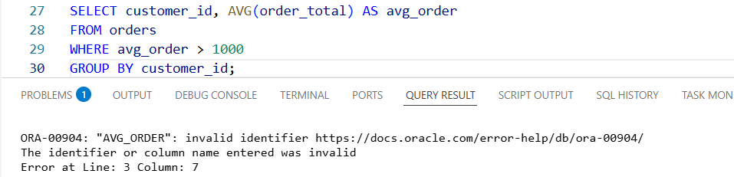

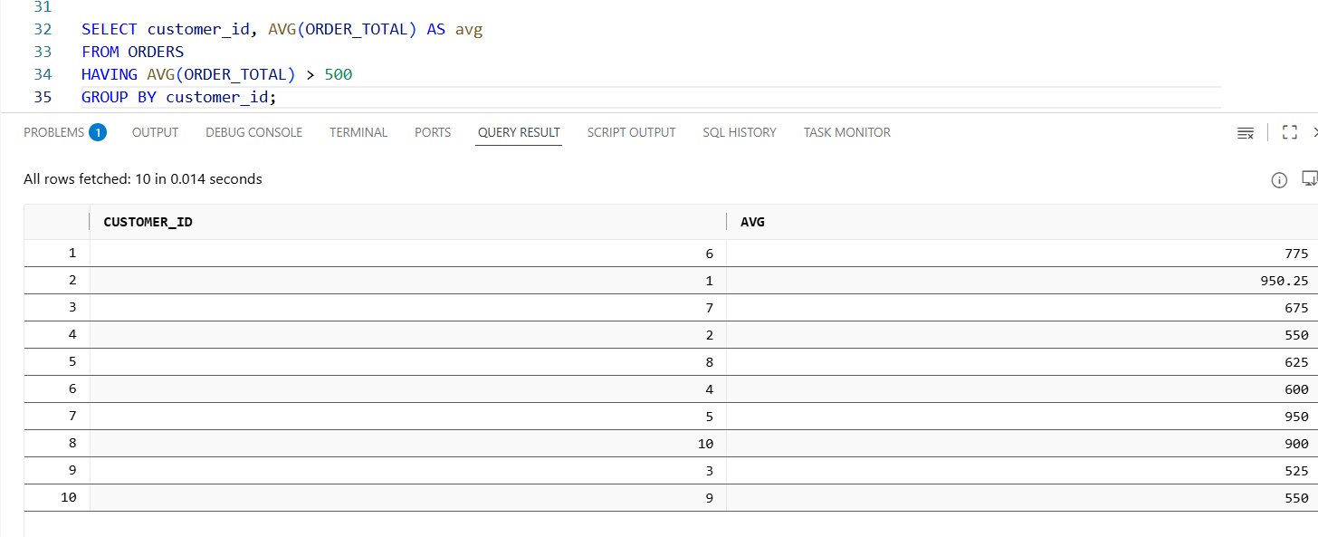

A: AVG is used correctly.

B: GROUP BY is already in correct place; WHERE comes before GROUP BY but that’s not the issue.

C: Correct: alias can't be used in WHERE because aggregation happens later.

D: No need to include customer_id inside AVG.

Q3.
Answer is D.

A: True. Counts all rows regardless of NULLs.

B: True. Only counts non-NULL values of that column.

C: True. Ignores duplicates and NULLs.

D: False. COUNT(column_name) ignores NULLs, COUNT(*) counts all rows.

Q4.
Answer is A.

A: Correct.
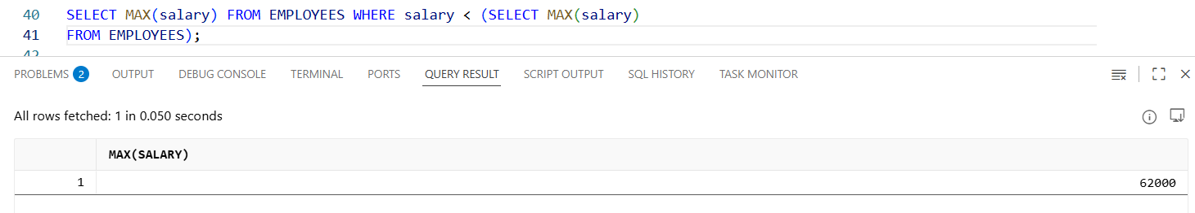

B: Works only in MySQL,not standard SQL.
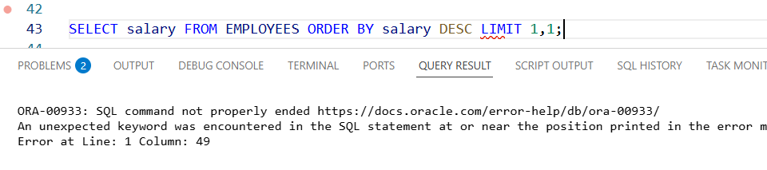

C: Correct but more complex.
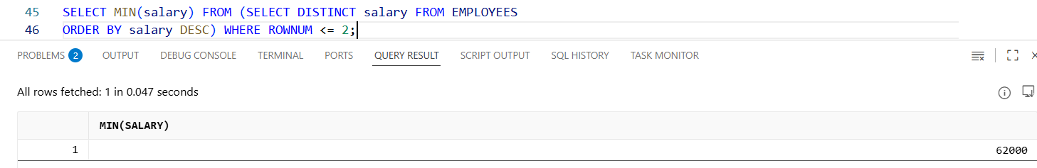

D: Also Correct.
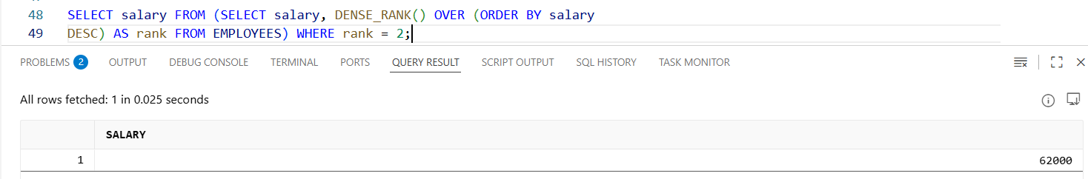

Q5.
Answer is B.

A: Incorrect.
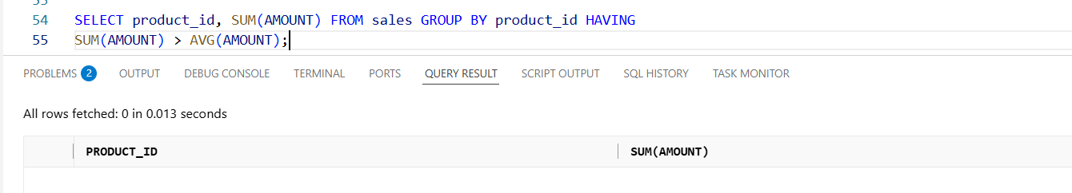

B: Correct.
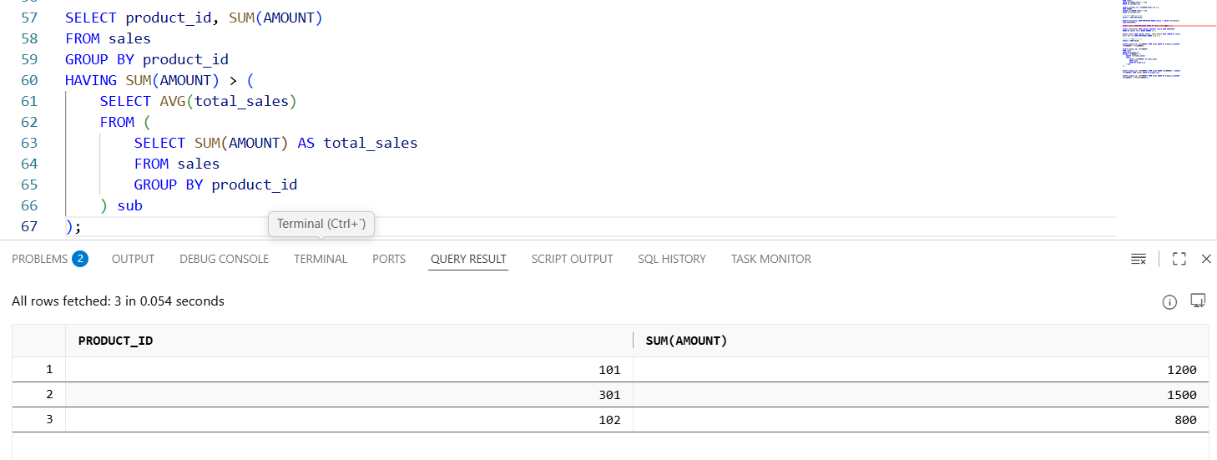

C: Incorrect syntax.
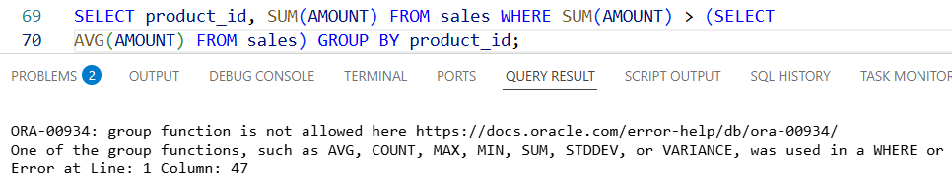

D: Incorrect.
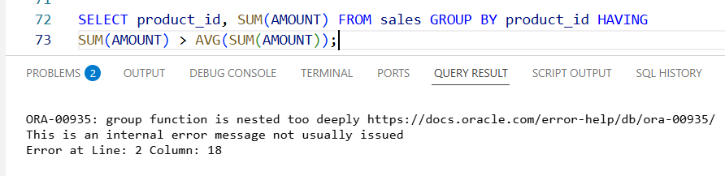

Q6.
Answer is C.

A: can’t use where after GROUP BY.
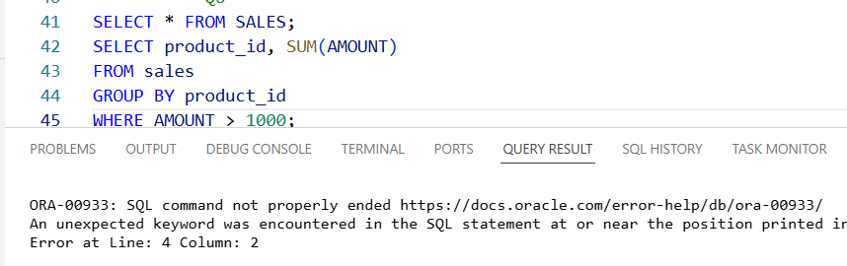

B: right syntax but wrong result.
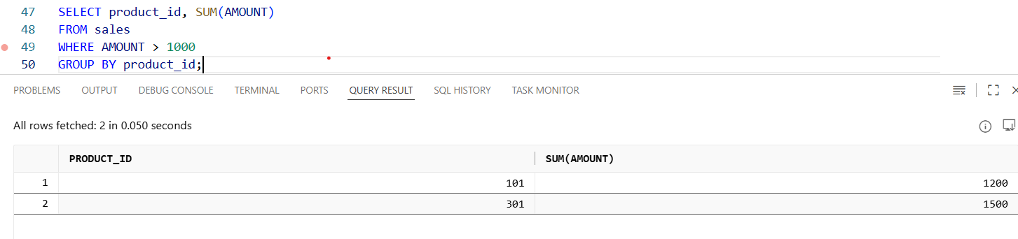

C: Correct.
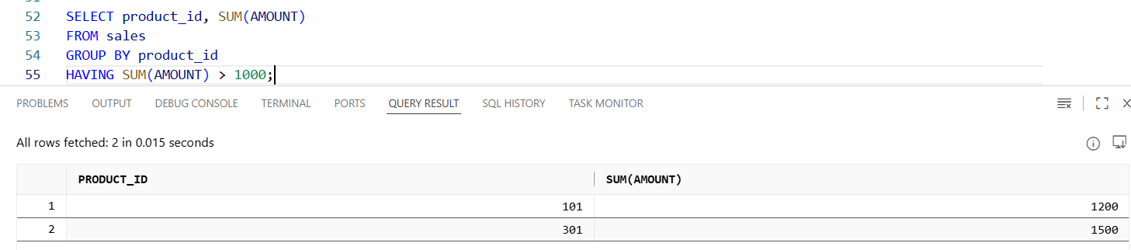

D: Also correct syntax in Oracle.
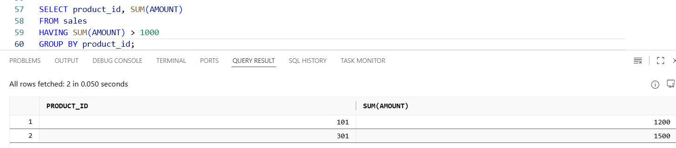

Q7.
Answer is A.

A: Correct.
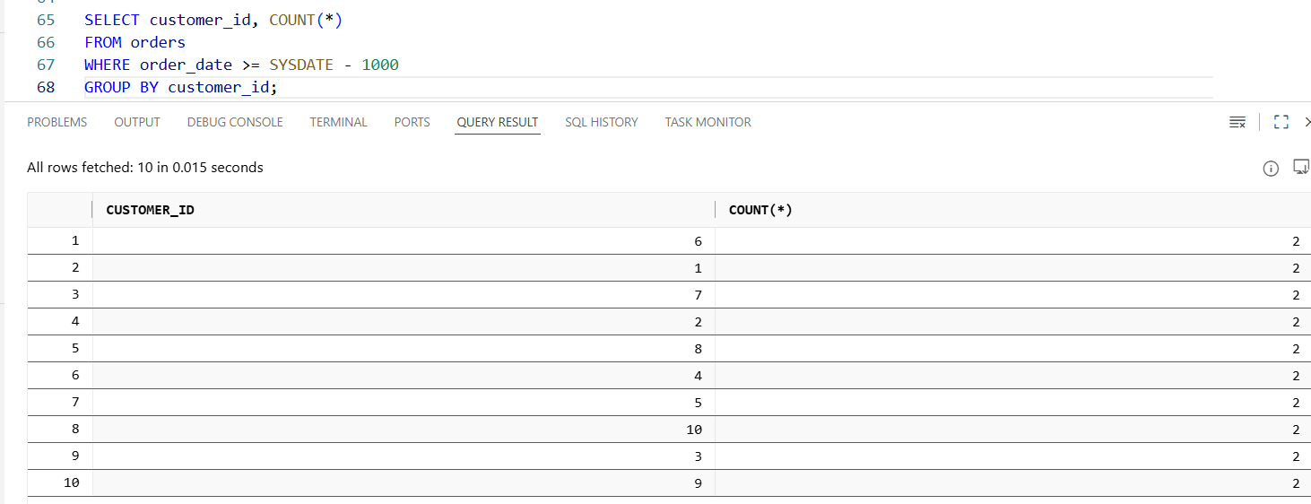

B: Incorrect use of HAVING.HAVING is used after aggregation to filter groups
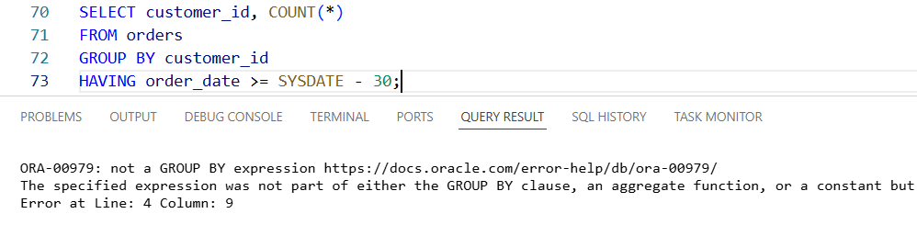

C: Incorrect. We need to count orders, not sum their IDs.
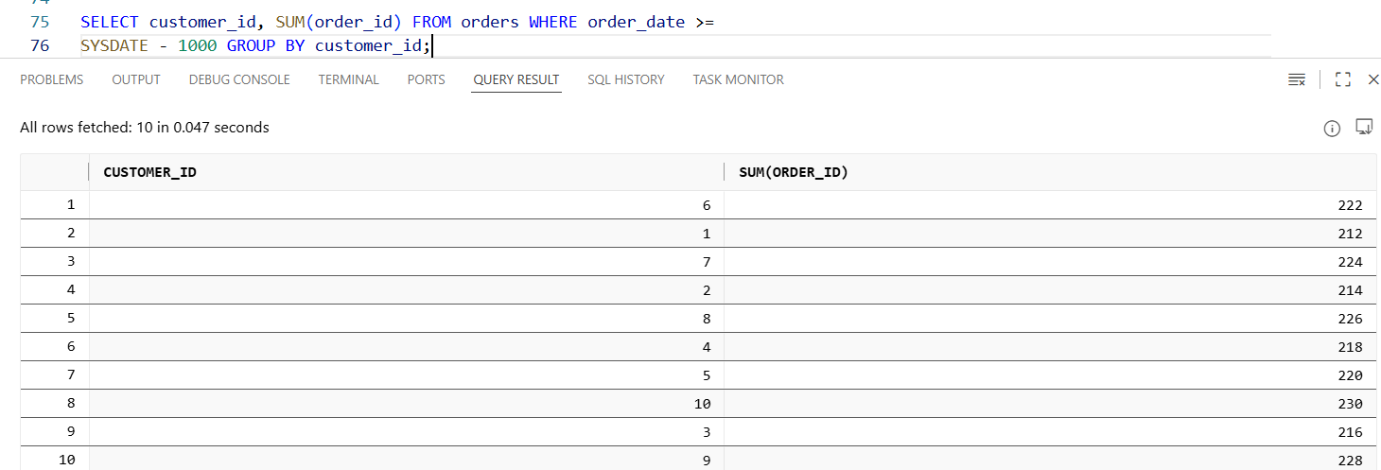

D: Incorrect syntax. Where must come before GROUP BY.
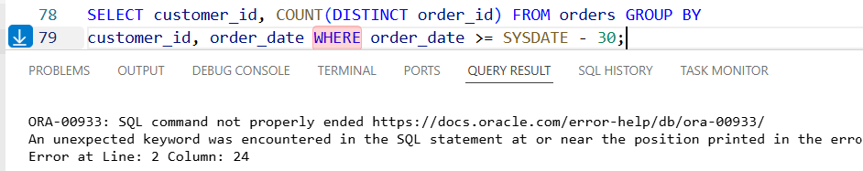

Q8.
Answer is A.

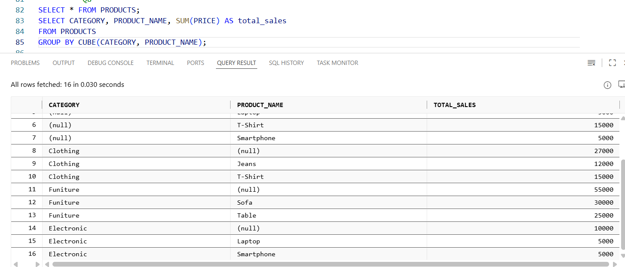

A: Correct. automatically generates subtotals by category, by region, and the grand total — exactly as required.

B: Produces hierarchical totals, not all combinations.But not subtotal for each region independently.

C: Correct but more complex — CUBE already does this automatically.

D: Not a valid modern SQL grouping extension for generating subtotals.

